# CS 255 System Design Document Template

## UML Diagrams

### UML Use Case Diagram

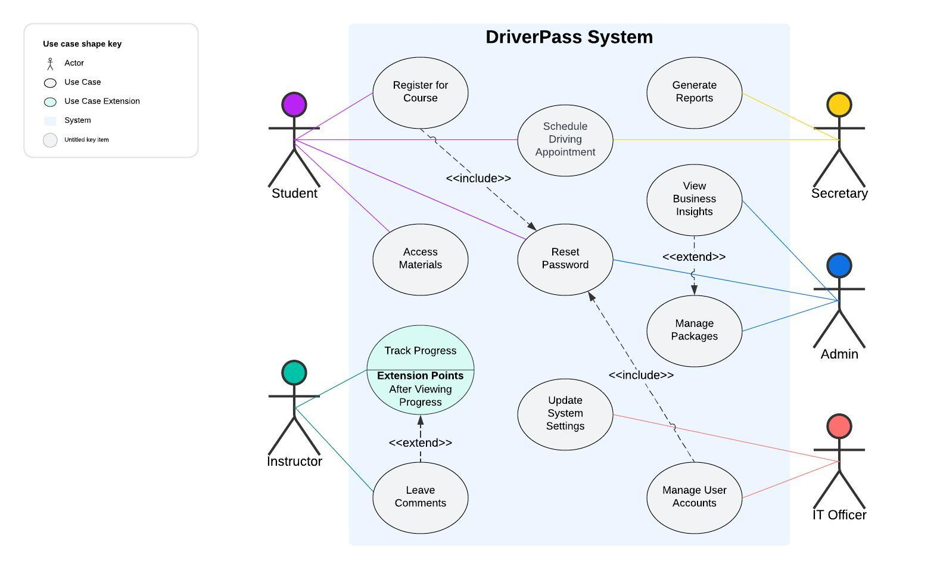

### UML Activity Diagrams

### UML Sequence Diagram

### UML Class Diagram

## Technical Requirements

Hardware Requirements:

* Web Server for hosting the application.
* Database Server for storing data.
* Client devices: Computers, tablets, or smartphones with internet access.

Software Requirements:

* Server OS: Linux or Windows Server.
* Client OS: Windows, macOS, iOS, Android.
* Frontend: HTML, CSS, JavaScript (React, Angular, or Vue.js).
* Backend: Node.js, Python (Django/Flask), or Java (Spring Boot).
* Database: AWS RDS or Google Cloud SQL.
* Web Server Software: Apache or Nginx.

Tools:

* IDE: Visual Studio Code, IntelliJ IDEA, or PyCharm.
* Version Control: Git and GitHub.
* UML Tool: Lucidchart.

Infrastructure Requirements:

* Reliable internet connection.
* Secure network configuration.
* SSL/TLS for secure data exchange.
* Role-based access control.
* Account lockout mechanisms.
* Cloud services (AWS, Azure, or Google Cloud).
* Load balancers.

Additional Considerations:

* Optimize for concurrent users.
* Modular architecture for adaptability.
* Regular updates for DMV compliance.